Non-Uniform Irregular-Faced Polyhedra

Definition
# Source: AI Source: Provided by: [Data Path: Persons Table -> ID Column: 1, Name_En Column: Motasem Essam] -> From: [ChatGPT] on [7/25/2026]
A Non-Uniform Irregular-Faced Polyhedron is a polyhedron whose faces include one or more irregular polygons and whose vertices are not all equivalent under the symmetry group of the polyhedron.
Unlike regular-faced polyhedra, its faces do not all have to be regular polygons. They may have unequal side lengths, unequal interior angles, or different geometric shapes.
Examples include irregular prisms, irregular pyramids, and polyhedra with mixed regular and irregular polygonal faces.
Important distinctions:
- Irregular-faced: At least one face is an irregular polygon.
- Non-uniform: The vertices are not all equivalent under the polyhedron's symmetry group.
- Non-uniform irregular-faced: The polyhedron has irregular faces and does not satisfy vertex transitivity.
A polyhedron can have irregular faces while retaining some symmetry. Non-uniformity does not mean that the solid has no symmetry at all.

Geometric Structure
# Source: AI Source: Provided by: [Data Path: Persons Table -> ID Column: 1, Name_En Column: Motasem Essam] -> From: [ChatGPT] on [7/25/2026]
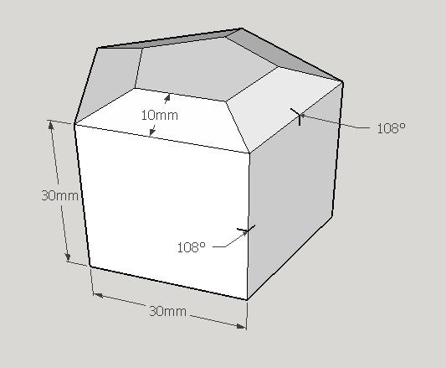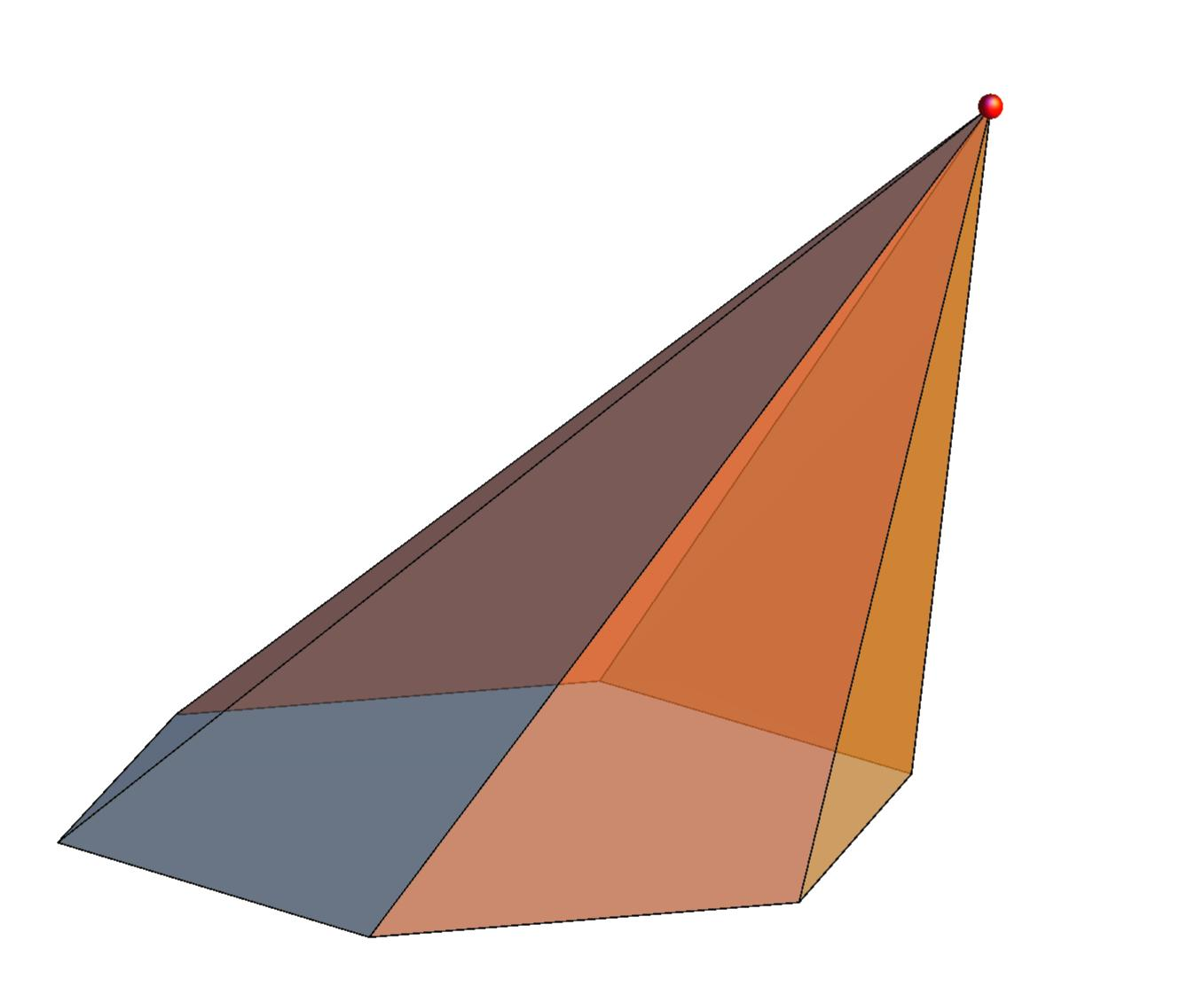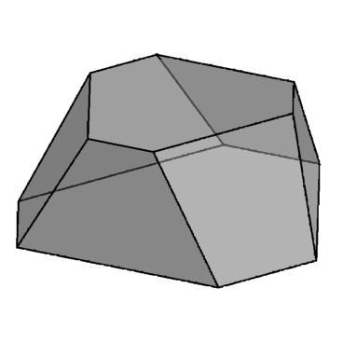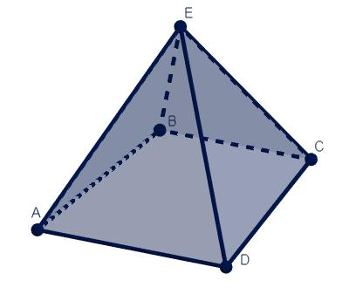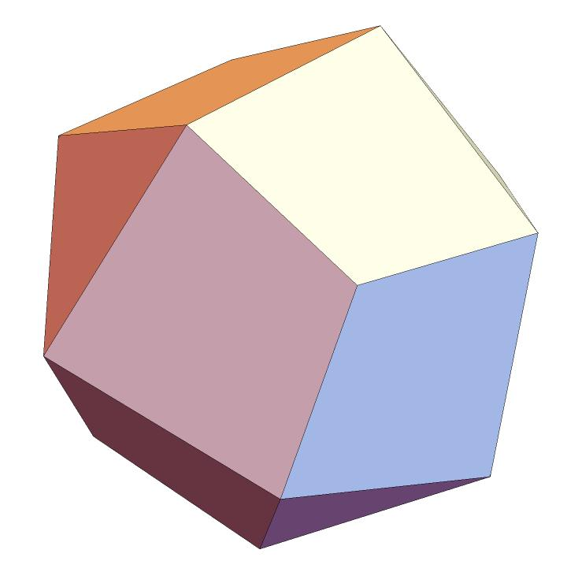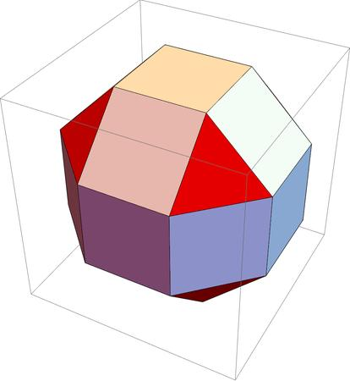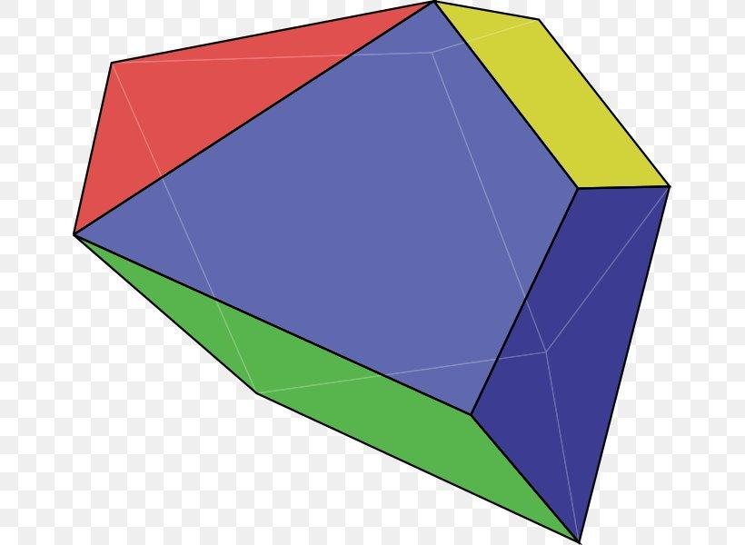

Main Characteristics
# Source: AI Source: Provided by: [Data Path: Persons Table -> ID Column: 1, Name_En Column: Motasem Essam] -> From: [ChatGPT] on [7/25/2026]
- Irregular Polygonal Faces: One or more faces have unequal side lengths or unequal interior angles.
- Non-Uniform Vertex Arrangement: The vertices are not all equivalent under the symmetry group.
- Variable Edge Lengths: Edges may have different lengths.
- Different Face Shapes: The polyhedron may contain triangles, quadrilaterals, pentagons, and other polygons.
- Variable Face Angles: Interior angles of individual faces may differ.
- Different Vertex Configurations: The number and arrangement of faces around vertices may vary.
- Variable Symmetry: The solid may have no nontrivial symmetry or may retain partial symmetry.
- Convex or Non-Convex Geometry: These polyhedra can have either convex or non-convex structures.

Types of Non-Uniform Irregular-Faced Polyhedra

Irregular Prisms
# Source: AI Source: Provided by: [Data Path: Persons Table -> ID Column: 1, Name_En Column: Motasem Essam] -> From: [ChatGPT] on [7/25/2026]
An Irregular Prism is a prism whose bases are irregular polygons. Its two bases are congruent and lie in parallel planes, while its lateral faces are generally parallelograms.
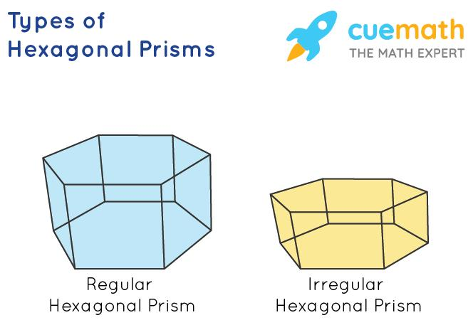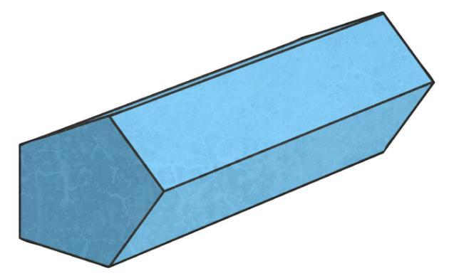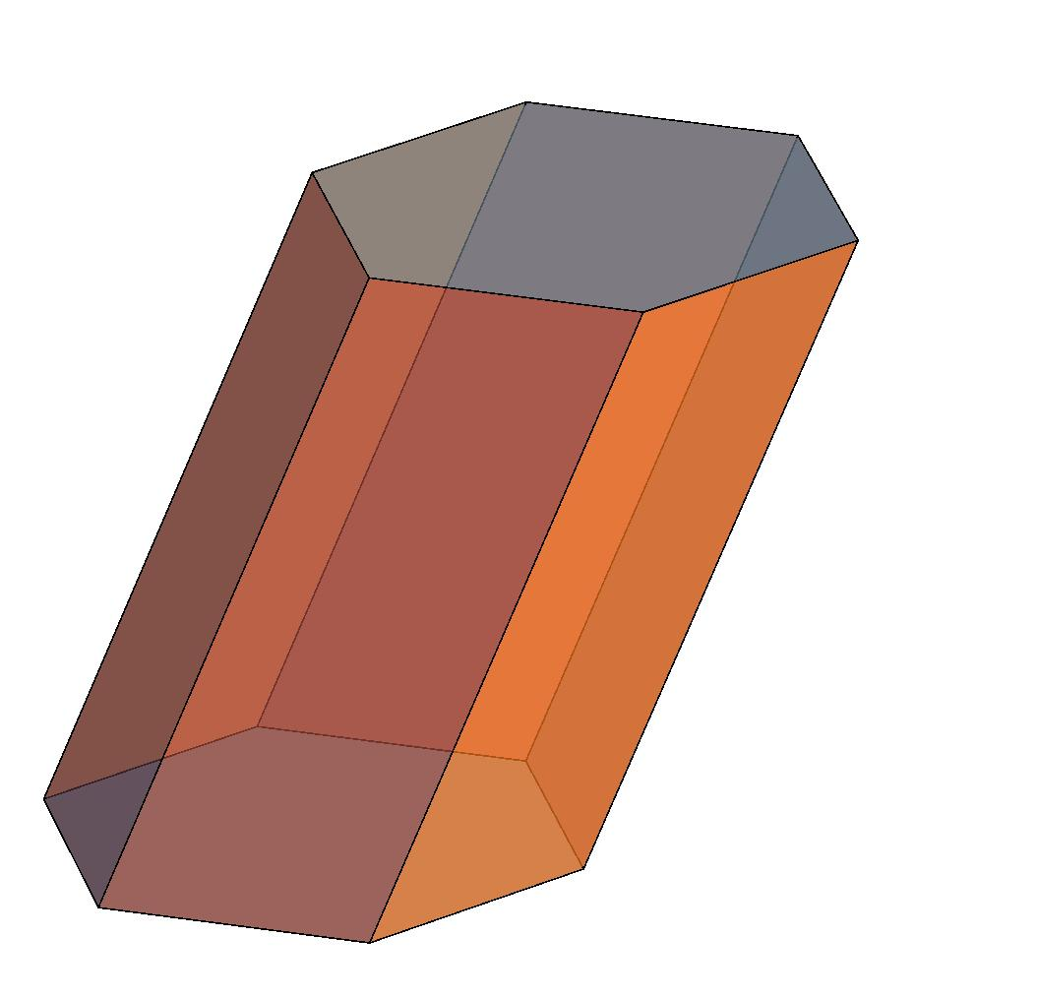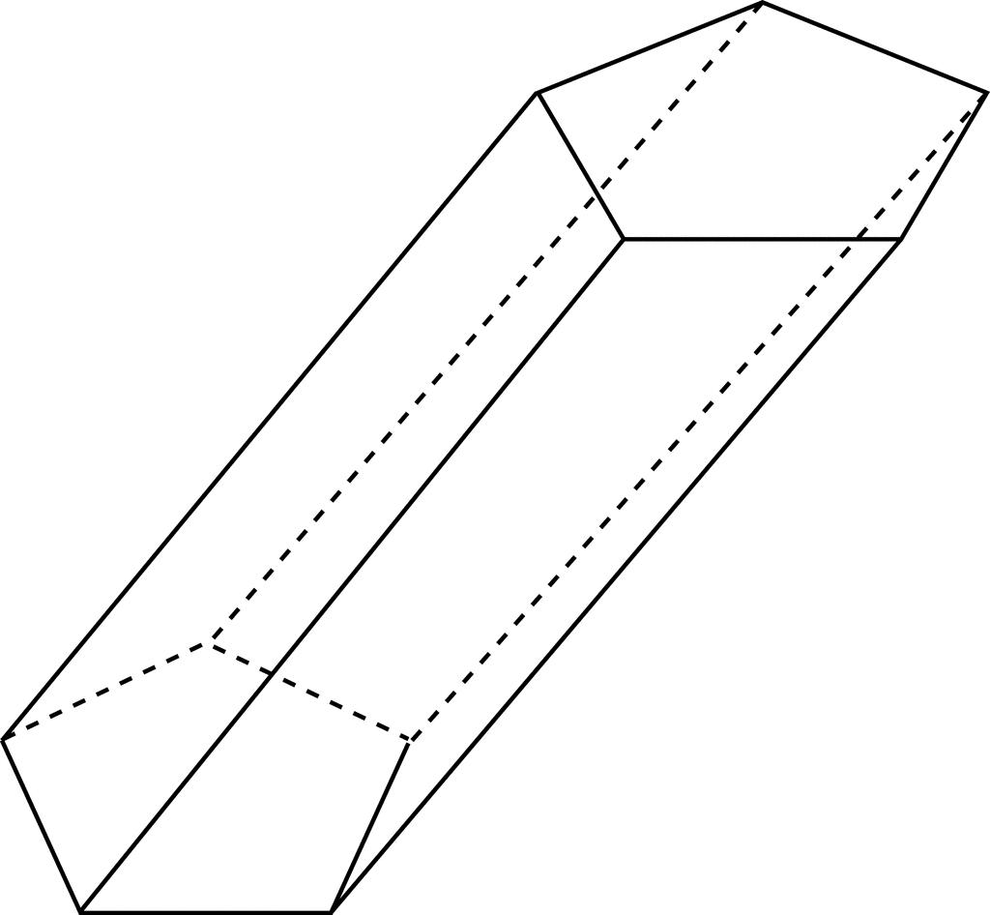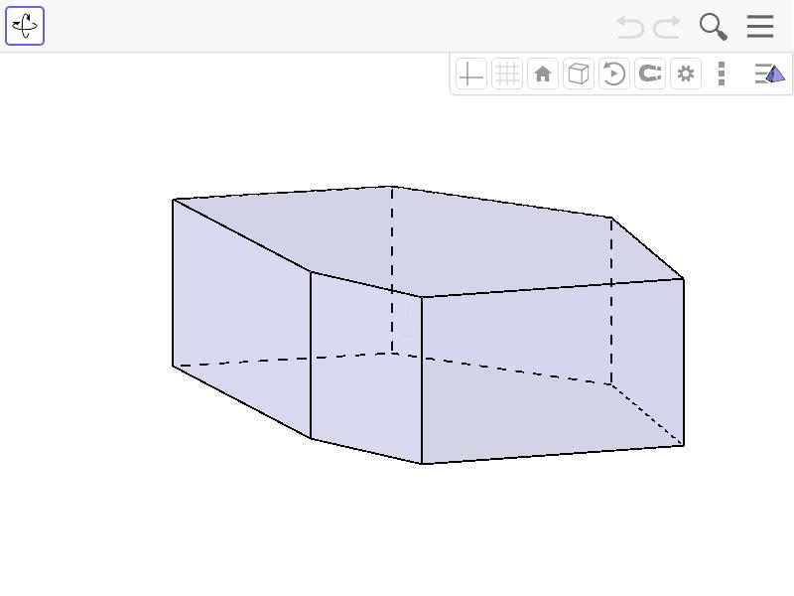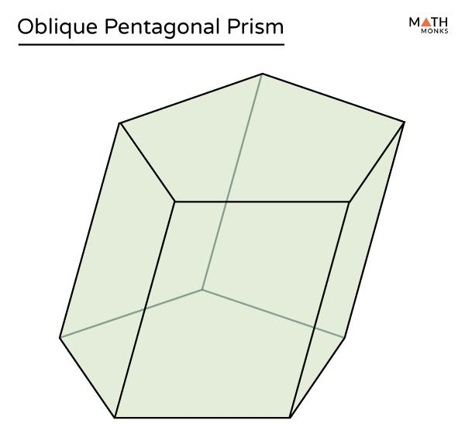
Characteristics:
- Two congruent, parallel irregular polygonal bases.
- Lateral faces are parallelograms.
- Base edges may have different lengths.
- The lateral faces may have different dimensions and shapes.
Examples:
- Irregular triangular prism.
- Irregular quadrilateral prism.
- Irregular pentagonal prism.
- Irregular hexagonal prism.
- Irregular n-gonal prism.

Irregular Pyramids
# Source: AI Source: Provided by: [Data Path: Persons Table -> ID Column: 1, Name_En Column: Motasem Essam] -> From: [ChatGPT] on [7/25/2026]
An Irregular Pyramid is a pyramid whose base is an irregular polygon, or whose lateral triangular faces are not all congruent regular triangles.
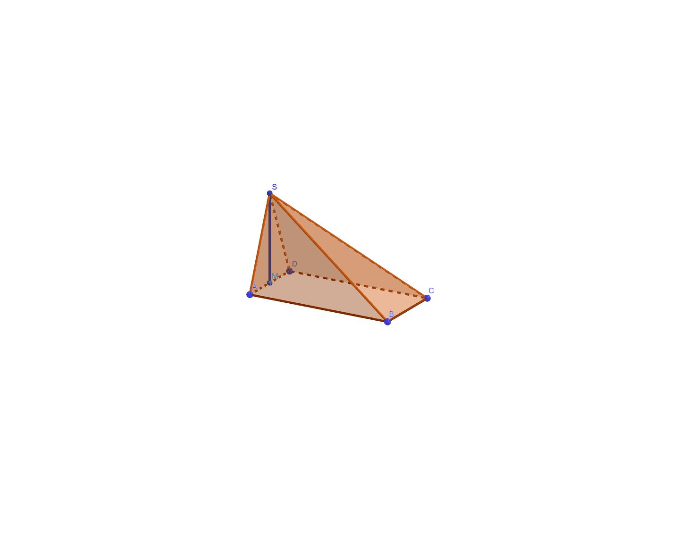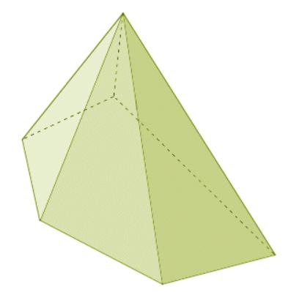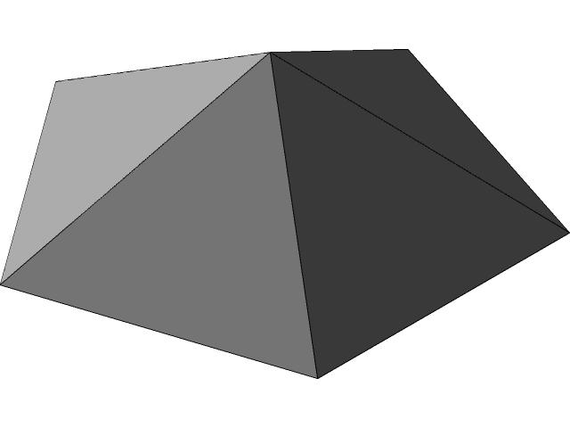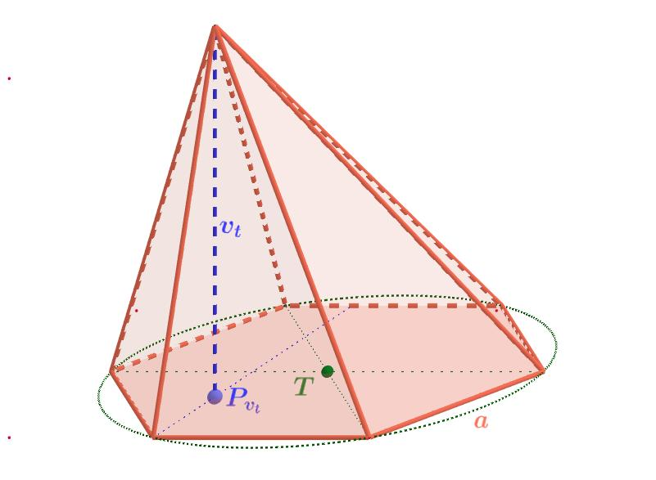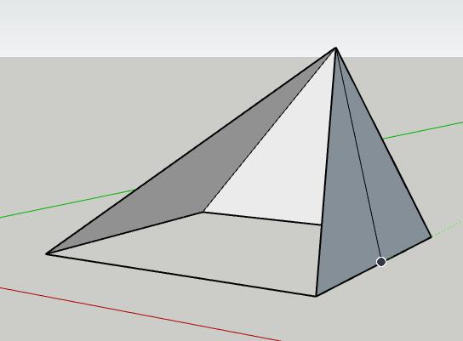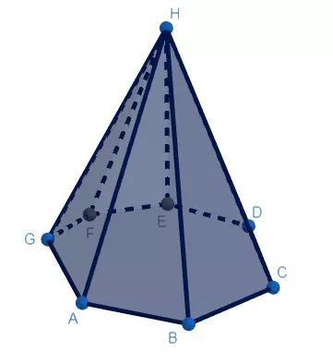
Characteristics:
- One polygonal base.
- Triangular lateral faces.
- The base may have unequal side lengths and angles.
- The lateral edges may have different lengths.
- The apex may be positioned away from the base's geometric center.
Examples:
- Irregular triangular pyramid.
- Irregular quadrilateral pyramid.
- Irregular pentagonal pyramid.
- Irregular hexagonal pyramid.
- Irregular n-gonal pyramid.

General Irregular-Faced Polyhedra
# Source: AI Source: Provided by: [Data Path: Persons Table -> ID Column: 1, Name_En Column: Motasem Essam] -> From: [ChatGPT] on [7/25/2026]
These are polyhedra whose faces are irregular polygons and which cannot necessarily be classified as ordinary prisms or pyramids.
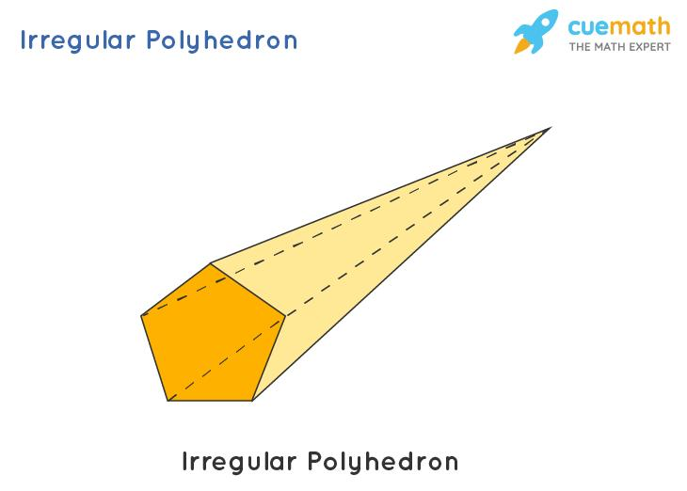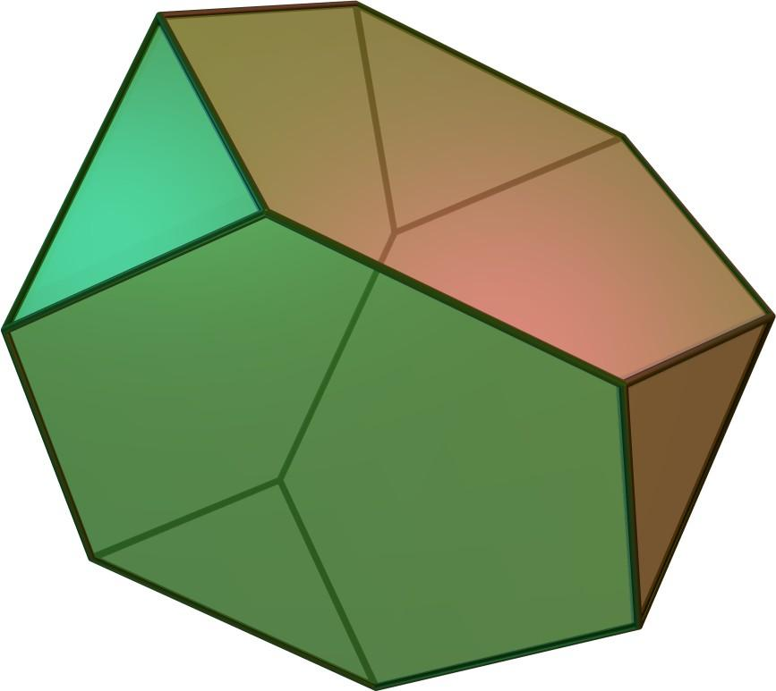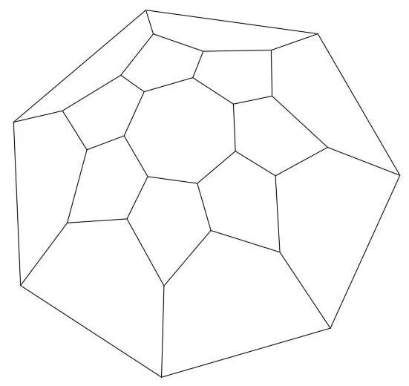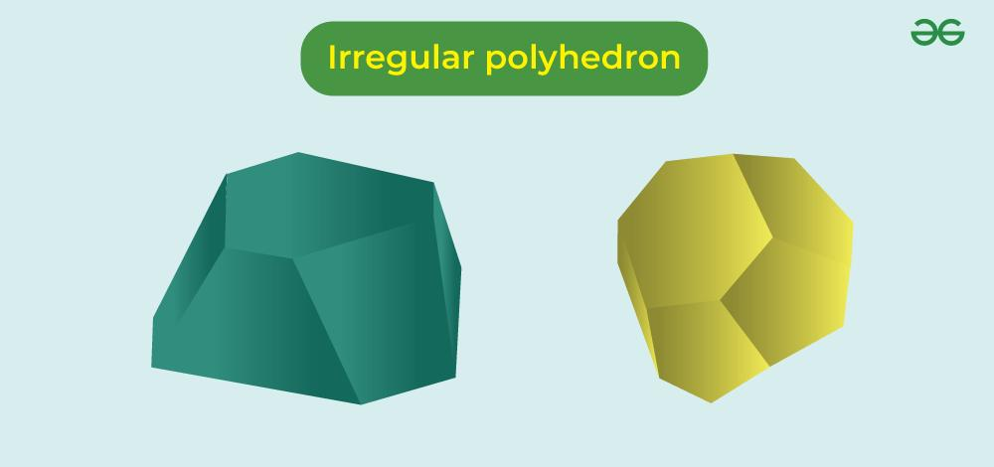
Characteristics:
- Different polygonal face shapes.
- Unequal edge lengths.
- Variable face angles.
- Different arrangements of faces around vertices.
- May have complex geometric structures.

Mixed Regular and Irregular-Faced Polyhedra
# Source: AI Source: Provided by: [Data Path: Persons Table -> ID Column: 1, Name_En Column: Motasem Essam] -> From: [ChatGPT] on [7/25/2026]
A Mixed Regular and Irregular-Faced Polyhedron contains both regular and irregular polygonal faces.
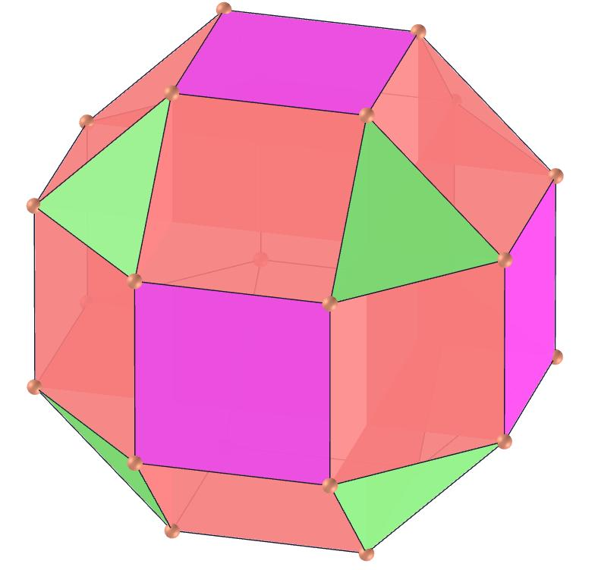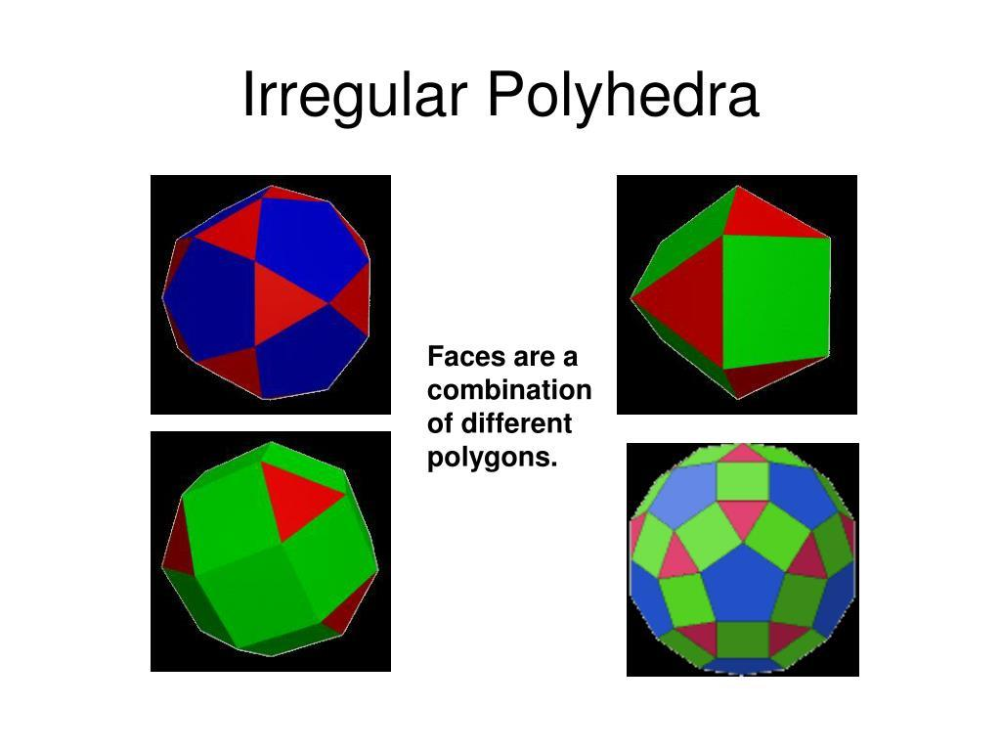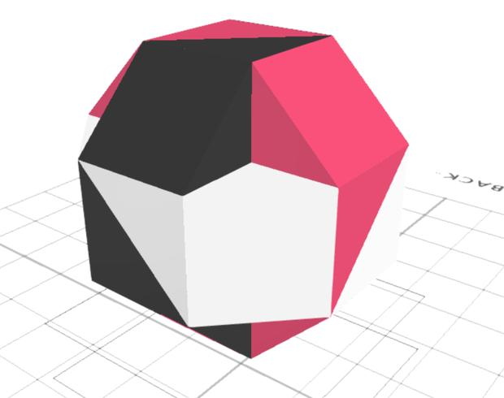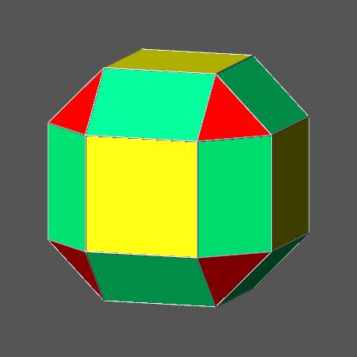
Characteristics:
- Some faces are regular polygons.
- Other faces are irregular polygons.
- Different face types may have different edge lengths.
- Vertex arrangements may vary.
- May be formed by joining or modifying different polyhedral components.

Composite Irregular-Faced Polyhedra
# Source: AI Source: Provided by: [Data Path: Persons Table -> ID Column: 1, Name_En Column: Motasem Essam] -> From: [ChatGPT] on [7/25/2026]
A Composite Irregular-Faced Polyhedron is formed by combining two or more polyhedral components in a way that produces an irregular-faced overall structure.
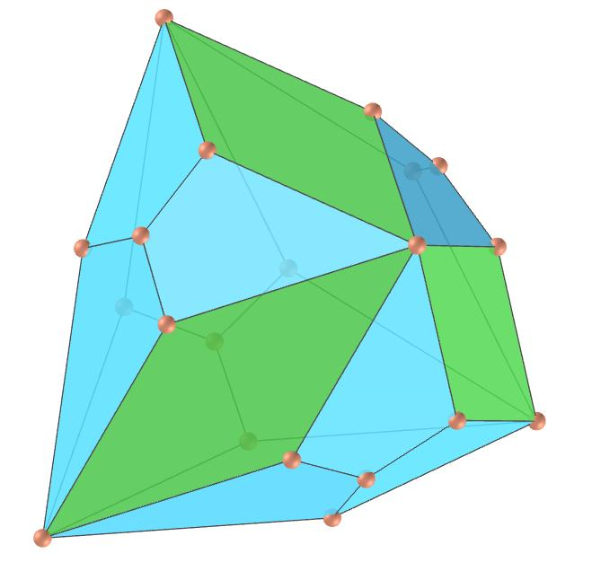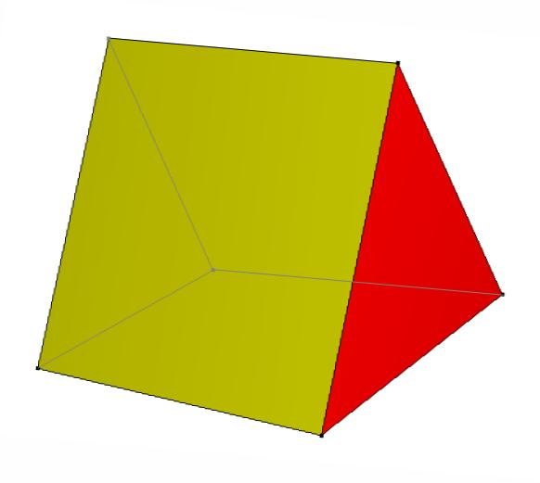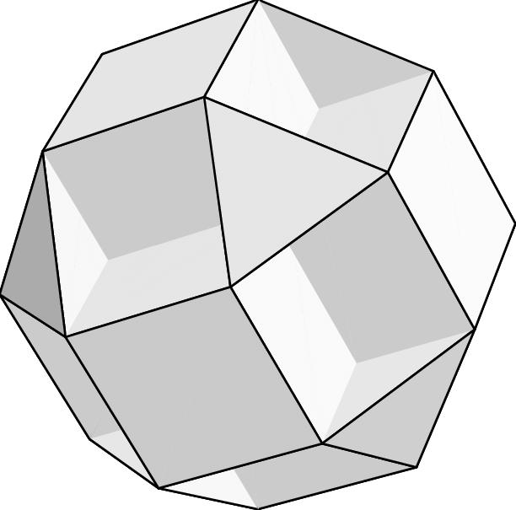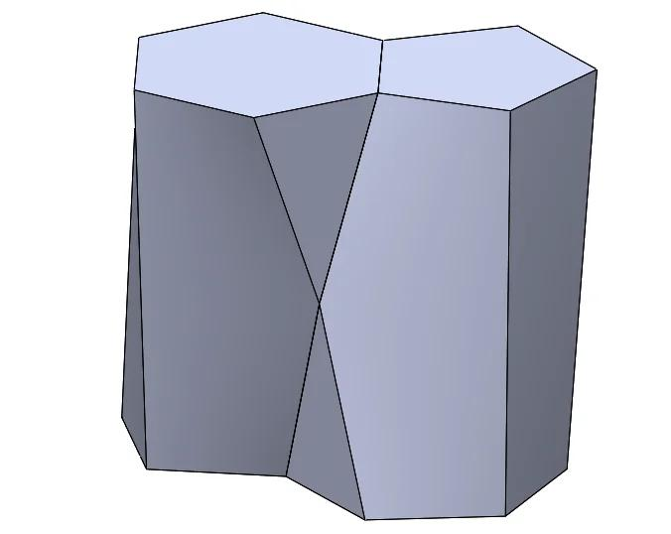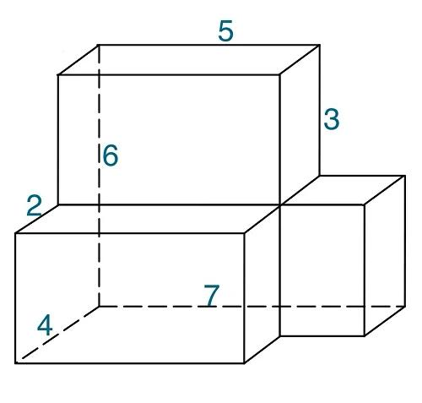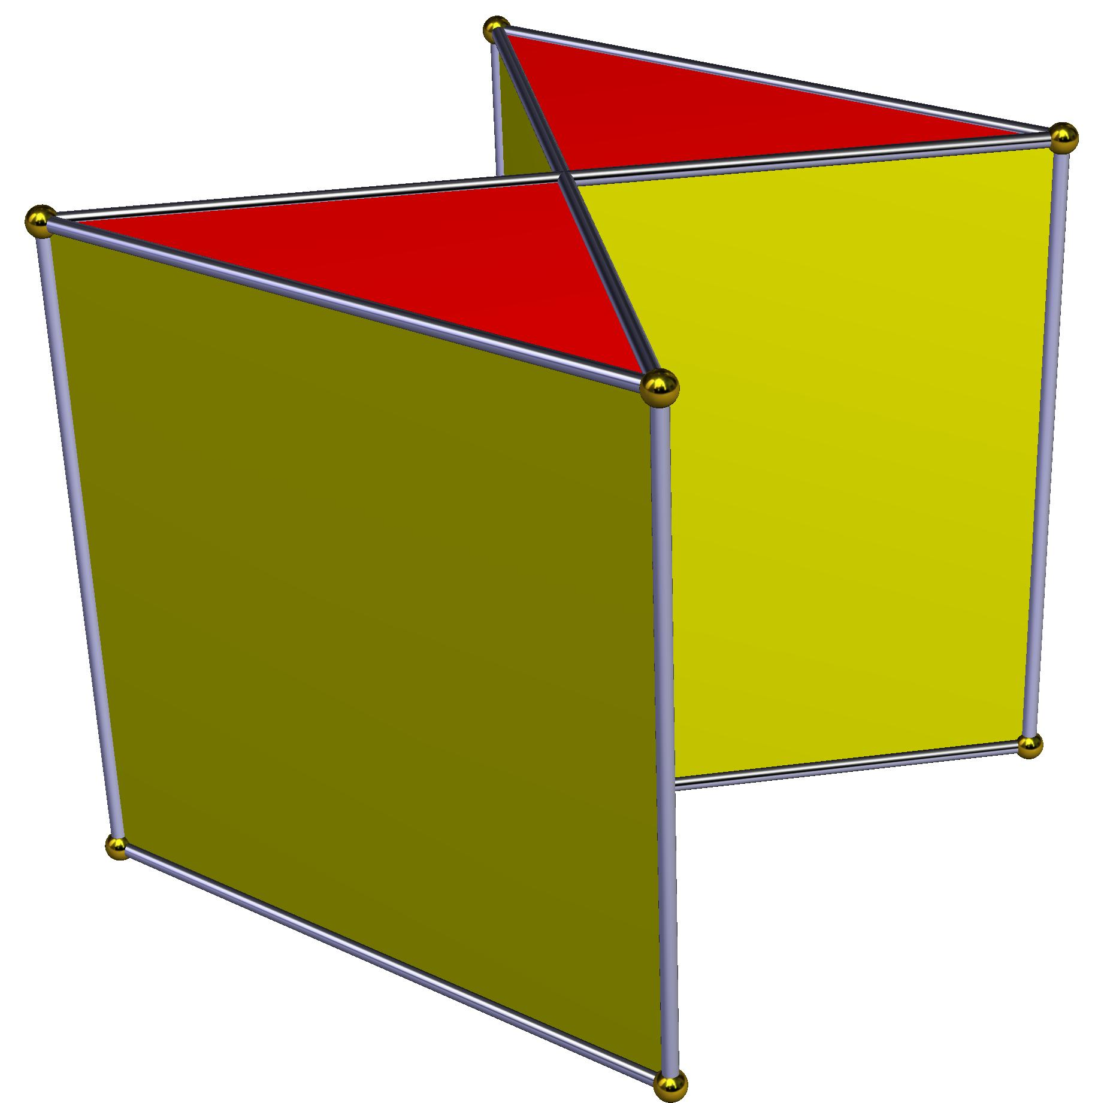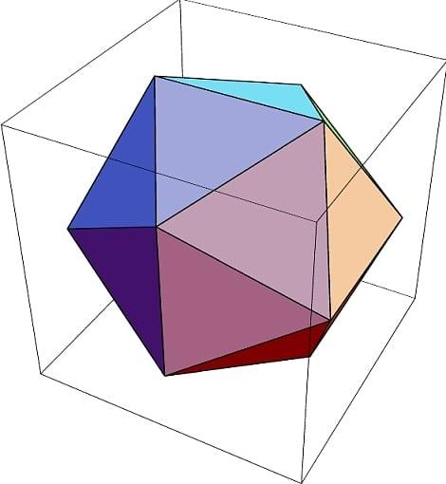
Possible construction methods:
- Joining irregular polyhedra.
- Combining prisms and pyramids.
- Joining polyhedra with different polygonal bases.
- Adding or removing polyhedral components.
- Combining components with different dimensions.

Non-Convex Irregular-Faced Polyhedra
# Source: AI Source: Provided by: [Data Path: Persons Table -> ID Column: 1, Name_En Column: Motasem Essam] -> From: [ChatGPT] on [7/25/2026]
A Non-Convex Irregular-Faced Polyhedron is an irregular-faced polyhedron whose overall structure is non-convex.
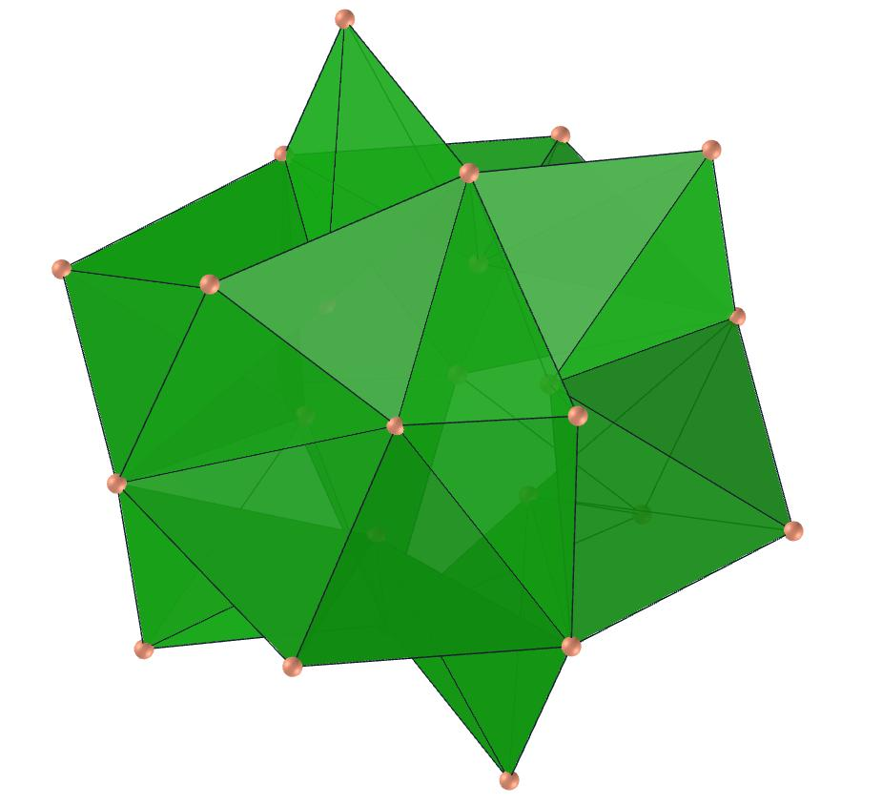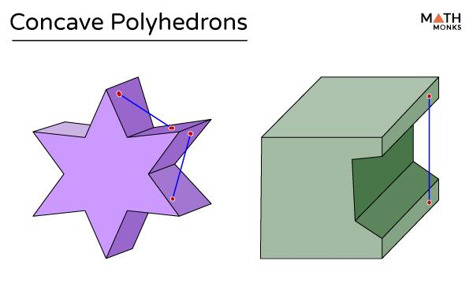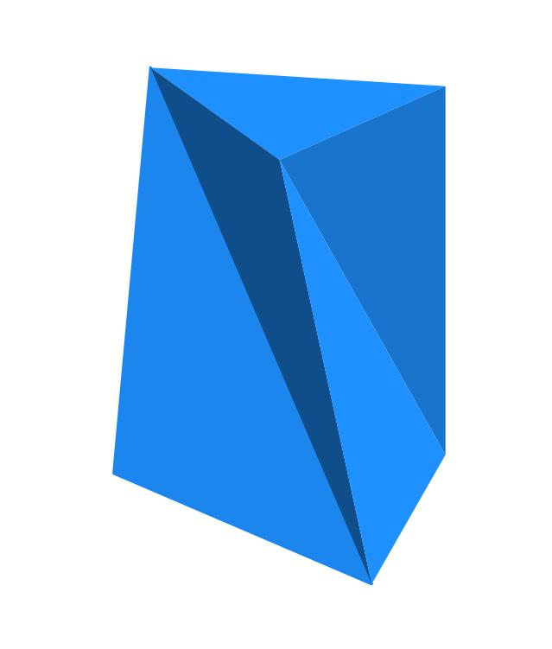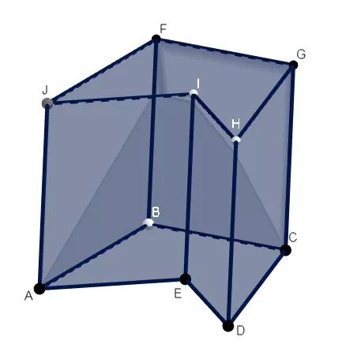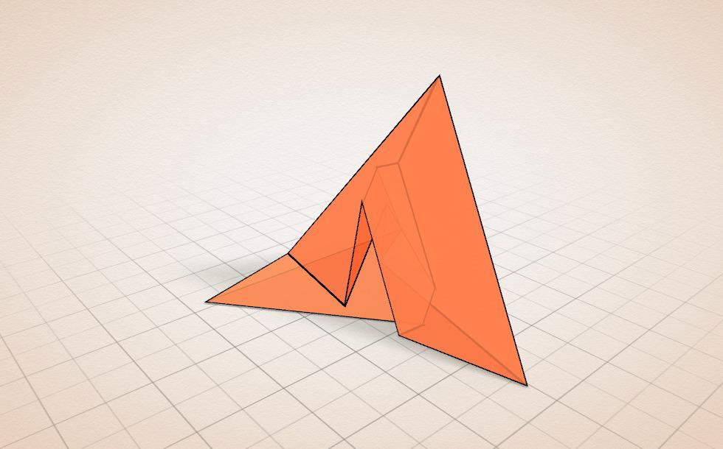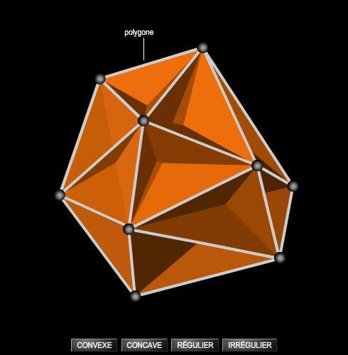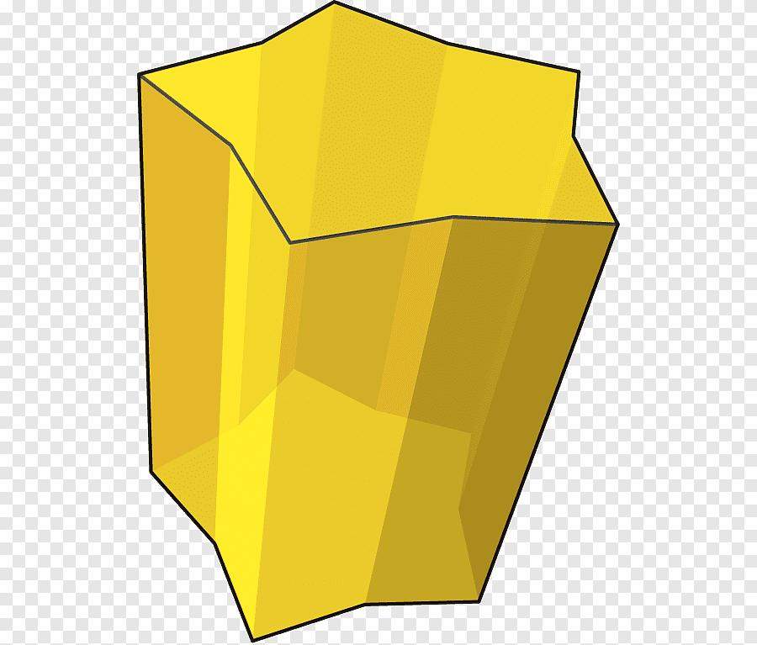
Characteristics:
- Contains one or more inward-facing or re-entrant regions.
- May have irregular polygonal faces.
- May contain different edge lengths and face angles.
- Some line segments connecting points of the solid may pass outside it.

Classification by Face Irregularity
# Source: AI Source: Provided by: [Data Path: Persons Table -> ID Column: 1, Name_En Column: Motasem Essam] -> From: [ChatGPT] on [7/25/2026]
Irregularity can also be classified according to the geometric properties of individual faces.
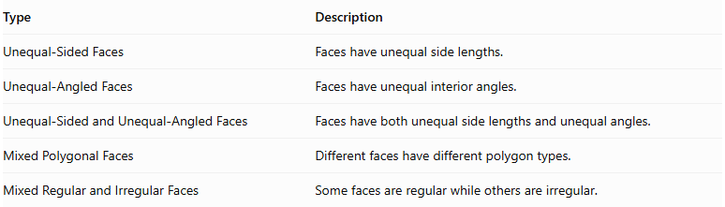
Type | Description
Unequal-Sided Faces | Faces have unequal side lengths.
Unequal-Angled Faces | Faces have unequal interior angles.
Unequal-Sided and Unequal-Angled Faces | Faces have both unequal side lengths and unequal angles.
Mixed Polygonal Faces | Different faces have different polygon types.
Mixed Regular and Irregular Faces | Some faces are regular while others are irregular.

Mathematical Characteristics
# Source: AI Source: Provided by: [Data Path: Persons Table -> ID Column: 1, Name_En Column: Motasem Essam] -> From: [ChatGPT] on [7/25/2026]
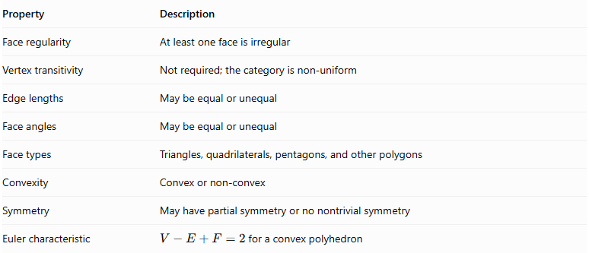
Property | Description
Face regularity | At least one face is irregular
Vertex transitivity | Not required; the category is non-uniform
Edge lengths | May be equal or unequal
Face angles | May be equal or unequal
Face types | Triangles, quadrilaterals, pentagons, and other polygons
Convexity | Convex or non-convex
Symmetry | May have partial symmetry or no nontrivial symmetry
Euler characteristic | $V-E+F=2$ for a convex polyhedron

Basic Mathematical Formulas
# Source: AI Source: Provided by: [Data Path: Persons Table -> ID Column: 1, Name_En Column: Motasem Essam] -> From: [ChatGPT] on [7/25/2026]
For an irregular prism:
$$V=A_{bh}$$
For an irregular pyramid:
$$V=\frac{1}{3}A_{bh}$$
Where:
- $V$ = Volume.
- $A_{b}$ = Area of the base.
- $h$ = Perpendicular height.
The base area must be calculated using the actual dimensions and shape of the irregular polygon.

Comparison: Regular-Faced vs. Irregular-Faced Polyhedra
# Source: AI Source: Provided by: [Data Path: Persons Table -> ID Column: 1, Name_En Column: Motasem Essam] -> From: [ChatGPT] on [7/25/2026]
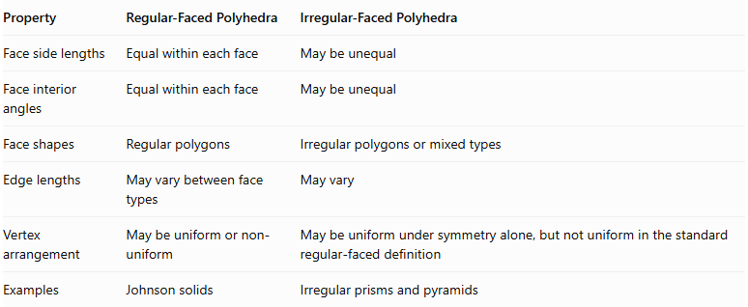
Property | Regular-Faced Polyhedra | Irregular-Faced Polyhedra
Face side lengths | Equal within each face | May be unequal
Face interior angles | Equal within each face | May be unequal
Face shapes | Regular polygons | Irregular polygons or mixed types
Edge lengths | May vary between face types | May vary
Vertex arrangement | May be uniform or non-uniform | May be uniform under symmetry alone, but not uniform in the standard regular-faced definition
Examples | Johnson solids | Irregular prisms and pyramids

Related Geometric Solids
# Source: AI Source: Provided by: [Data Path: Persons Table -> ID Column: 1, Name_En Column: Motasem Essam] -> From: [ChatGPT] on [7/25/2026]
- Irregular Prisms – Prisms with irregular polygonal bases.
- Irregular Pyramids – Pyramids with irregular bases or lateral geometry.
- Oblique Prisms – Prisms whose lateral edges are inclined to their bases.
- Oblique Pyramids – Pyramids whose apex is not directly above the base center.
- Composite Polyhedra – Polyhedra assembled from multiple components.
- Concave Polyhedra – Polyhedra with non-convex geometry.

Main Classification
# Source: AI Source: Provided by: [Data Path: Persons Table -> ID Column: 1, Name_En Column: Motasem Essam] -> From: [ChatGPT] on [7/25/2026]
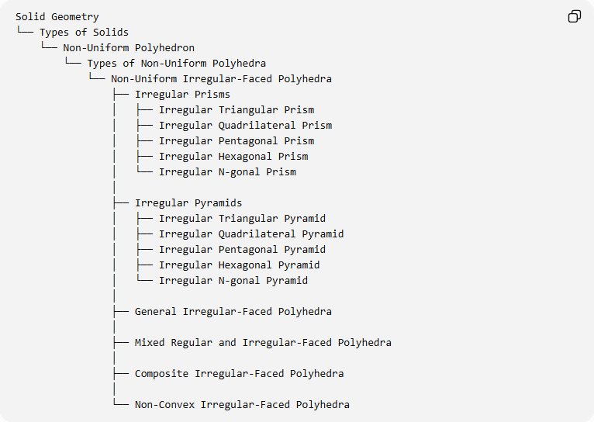
Solid Geometry
└── Types of Solids
└── Non-Uniform Polyhedron
└── Types of Non-Uniform Polyhedra
└── Non-Uniform Irregular-Faced Polyhedra
├── Irregular Prisms
│ ├── Irregular Triangular Prism
│ ├── Irregular Quadrilateral Prism
│ ├── Irregular Pentagonal Prism
│ ├── Irregular Hexagonal Prism
│ └── Irregular N-gonal Prism
│
├── Irregular Pyramids
│ ├── Irregular Triangular Pyramid
│ ├── Irregular Quadrilateral Pyramid
│ ├── Irregular Pentagonal Pyramid
│ ├── Irregular Hexagonal Pyramid
│ └── Irregular N-gonal Pyramid
│
├── General Irregular-Faced Polyhedra
│
├── Mixed Regular and Irregular-Faced Polyhedra
│
├── Composite Irregular-Faced Polyhedra
│
└── Non-Convex Irregular-Faced Polyhedra
Classification note: These subdivisions are a proposed organizational taxonomy for studying irregular-faced polyhedra, not a universally standardized mathematical classification. A prism or pyramid can also be classified by its obliqueness, convexity, or base shape independently.

Key Points
# Source: AI Source: Provided by: [Data Path: Persons Table -> ID Column: 1, Name_En Column: Motasem Essam] -> From: [ChatGPT] on [7/25/2026]
- Non-uniform irregular-faced polyhedra contain at least one irregular polygonal face.
- Their edges and face angles may have different measurements.
- They include irregular prisms, irregular pyramids, general irregular-faced polyhedra, and composite structures.
- They may be convex or non-convex.
- Mixed regular and irregular-faced polyhedra combine both face categories.
- Irregularity of the faces and non-uniformity of the vertices are separate geometric properties.

Conclusion
# Source: AI Source: Provided by: [Data Path: Persons Table -> ID Column: 1, Name_En Column: Motasem Essam] -> From: [ChatGPT] on [7/25/2026]
Non-Uniform Irregular-Faced Polyhedra form a broad category of polyhedra characterized by irregular polygonal faces and the absence of the complete requirements of uniformity. Their structures range from simple irregular prisms and pyramids to complex composite and non-convex polyhedra.
Sources for mathematical background:
- Norman W. Johnson, Convex Polyhedra with Regular Faces.
- Grünbaum and Johnson, The Faces of a Regular-Faced Polyhedron.
- Polyhedra and Non-Polyhedra – Geometry Terminology.

